EAD CA 2

Philip O’Donovan, Howie Lynch

***Source code***: <https://github.com/PhilOD96/RecipeAPI>

***Service URL Scheme***:

*Extracts all recipes from DB*

<https://ca2recipeapi.azurewebsites.net/api/recipes/all>

*Extracts relevant Recipe for ID, where id 0 to 9*

[https://ca2recipeapi.azurewebsites.net/api/recipes/{id}](https://ca2recipeapi.azurewebsites.net/api/recipes/%7bid%7d)

*Extract relevant Recipe where name can be “Sandwich”, “Moussaka” etc..*

[https://ca2recipeapi.azurewebsites.net/api/recipes/recipeName/{name}](https://ca2recipeapi.azurewebsites.net/api/recipes/recipeName/%7bname%7d)

***Screenshots***

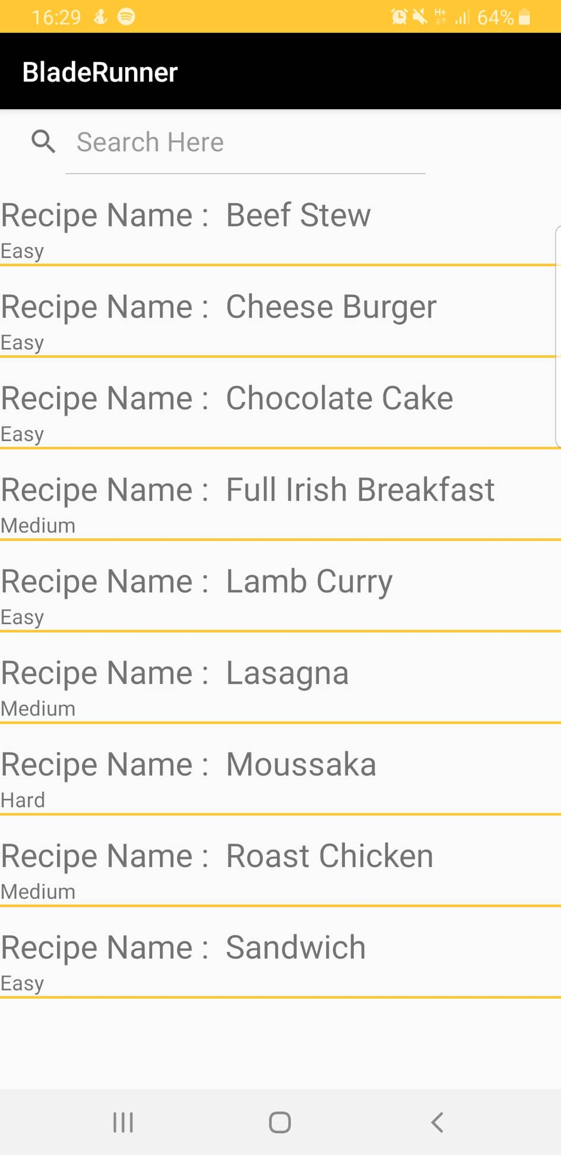

***Azure Deployment***

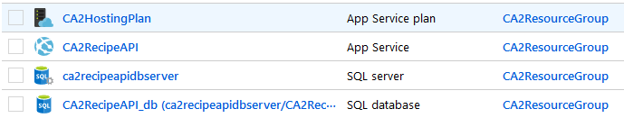Using Free Tier for all resources

***Espresso Tests***

